L12: Preparation Assignment Answer Key

Part I: Concepts
- What does it mean to have Matched Pair data?
Usually matched pairs are data taken from one population where a pair of observations is drawn on the same individuals selected for the sample, such as a pre-test and post-test.
- What are the differences in the hypothesis tests between a One Sample t (σ unknown) and Matched Pairs t (open-ended)?

Part II: Application
Matched Paired t Procedure - A manager at a factory feels that the amount of time that his workers spend doing their part in the assembly line is too long. He measures the amount of time (in minutes) nine of his workers take to complete 100 products. After implementing the new procedure, he again measures the amount of time (in minutes) the same nine workers take to complete 100 products, and obtains the following data: He wants to know if the mean assembly time is different and used the level of significance of α = 0.05. (Use Data link in I-Learn “FactoryAssemblyTimes-sim” SPSS for 221B and 221C and Excel for 221A)

- Design the Study:
- What is the research question?
After implementing the new loading/unloading procedure, is the mean wait time different than the wait time before?
- State the null and alternative hypothesis.
$$H_{o}: μ_{d }=0$$
$$H_{a}: μ_{d }≠0$$
- Collect the Data:
- Describe the data collection procedures.
The researcher collected assembly times (in minutes) from nine factory workers before the change. Then he collected the assembly times for those same nine workers after the change in procedure had been implemented.
- Describe the Data:
- In a short paragraph use summary statistics to describe the data. After the paragraph insert an appropriate and well labeled graph to illustrate the data.
Students should have a paragraph to summarize the statistics. They should include:
$\overline{d}=±1.056$ (Depending on which way you subtracted, pre – post or post – pre) $s_{d }=2.596$, , n = 9. Also, they could include one hisogram of the differences and one histogram each of the original data sets. Be sure their graphs are clearly labeled.
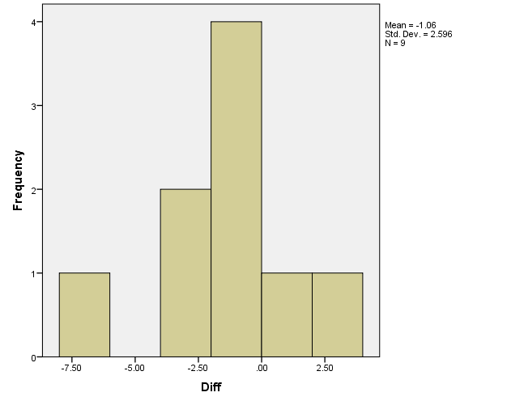

- Make Inferences:
- What type of hypothesis test is appropriate?
A two tailed, paired-sample t-test for Means is the appropriate hypothesis test to perform.
- What are the requirements for this test?
That the sample mean of the differences comes from a normal distribution
- Compute the differences between the two times and determine if the requirements are met for this test? Explain your answer.
We assume a simple random sample of the population. n < 30 so we would need to make a QQ plot in order to test the normality of the data. The differences are not very normally distributed, so the requirement is not met.
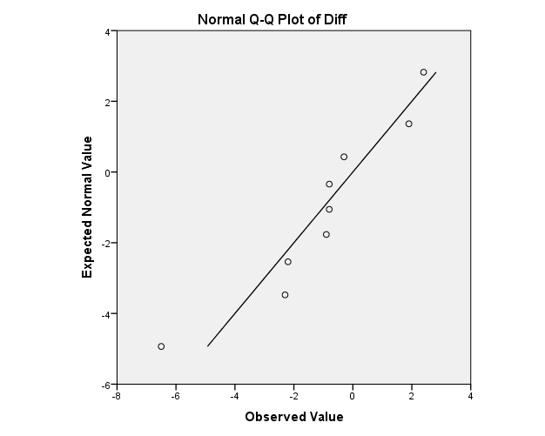
- Continue with the test regardless of what you found in part c. Compute the test statistic.
t = 1.22 or -1.22
- State the degrees of Freedom.
df = 8
- Compute the P-value to the alpha level.
P-value = 0.257 P-value > α
- Make a decision. Do you reject the null hypothesis or fail to reject it?
P-value > α, therefore we fail to reject the null hypothesis.
- Present your conclusions in the form of an English statement.
We have insufficient evidence to say that the time to make 100 products is any different after the implementation of the new assembly procedure.

- Rather than testing a hypothesis, now say you just wanted to estimate the mean difference between wait times at the 95% level. What would you do? Do it and paste your results below.

We would create a 95% confidence interval using the T-distribution.
(-3.0508, 0.9397) or (-0.9397, 3.0508)
- Take Action
In a short paragraph describe the action you feel should be taken based on the statistical results above.
You should describe how they need to find another way to reduce the time, because this particular plan didn’t make a statistically significant difference.

